**SMART FASHION RECOMMENDER**

|  |  |
| --- | --- |
| **STUDENT NAME** | **NANDHAKUMAR K K**  **AMRIS SARTHY C V**  **MOHAMED ALIM S**  **KIRITHIC SA** |
| **TEAM ID** | **PNT2022TMID23026** |

SOLUTION ARCHITECTURE

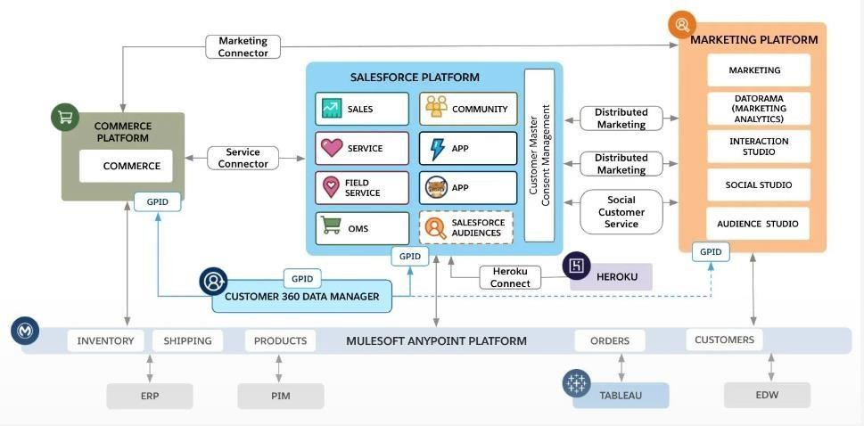

**What Is the Salesforce Architecture?**

* By now you know that you can use Salesforce to deliver a highly customized experience to your customers, employees, and partners. You can do it without writing much (or any) code, and you can do it fast.
* Salesforce is a cloud company. Everything we offer resides in the trusted, multitenant cloud.
* All our apps sit on top of the platform. Our prebuilt offerings like Sales Cloud and Marketing Cloud, along with apps you build using the platform, have consistent, powerful functionality.
* Everything is integrated. Our platform technologies like predictive analytics and the development framework are built into everything we offer and everything you build.

**Why Trust the Cloud?**

* At Salesforce, **trust** is our top priority. Not only are you keeping your

sensitive data in your org, you’re also building functionality vital to your

company’s success on our platform. Our responsibility to keep your data and functionality safe is not something we take lightly, which is why we’re always transparent about our services.

* Our trust site, [trust.salesforce.com,](https://trust.salesforce.com/en/) is a vital resource. You can use it to view performance data and get more information about how we secure your data. It also shows you any planned maintenance we’ll be performing that might impact your access to Salesforce.

# The Magic of Metadata

* To put it simply, **metadata** is data about data. Wait. That’s not simple at all. When we say data about data, we’re really talking about the structure of your Salesforce org.
* Let’s think about an object like Property. When our friends at DreamHouse use Salesforce, they input and view data about properties.

# All About That API

* Fundamentally, **APIs** allow different pieces of software to connect to each other and exchange information.
* If that sounds kind of abstract, take a quick look at the computer you’re working on right now. You can probably find a series of ports of various shapes and sizes that support different kinds of connections. These are like the hardware version of APIs. You don’t have to know how the USB port works. All you have to understand is that when you plug your phone into a USB port, it passes information to your computer.
* APIs are similar. Without knowing the details, you can connect your apps with other apps or software systems. The underlying technology takes care of the specifics of how information passes throughout the system.
* So what does this have to do with Salesforce?
* Earlier, we talked about the database. When you add a custom object or field, the platform automatically creates an API name that serves as an access point between your org and the database. Salesforce uses that API name to retrieve the metadata and data you’re looking for.
* For example, we can use a contact’s Name field in a bunch of places, like the Salesforce mobile app, a custom page, or even an email template. That’s all possible because of the API.